**Brainstorm & Idea Prioritization**

**Brainstorm & Idea Prioritization**

|  |  |
| --- | --- |
| 📅 Date | 30JUNE 2025 |
| 👥 Team ID | LTVIP2025TMID31307 |
| 👥 Team Size | 4 |
| 👑 Team Leader | K Veera Venkkateshh |
| 👤 Team Members | - G Satya Veera Durga Prasad  - K Manikanta  - K Vikhitha |
| 📌 Project Name | Public Transport Management System |

**Step 1: Team Gathering, Collaboration, and Select the Problem Statement**

The team conducted collaborative sessions involving Salesforce admins, Transport Department stakeholders, and operational managers to analyze existing challenges in public transport management. After discussions, the selected problem statement was:

“Our organization struggles with manual tracking and disparate data related to employees, bus stations, buses, ticket fares, and daily trip operations. This leads to inefficiencies, data inconsistencies, lack of real-time visibility into passenger counts and revenue, and challenges in overall operational management. There is a need for a centralized, automated solution on Salesforce to streamline and enhance Public Transport Administration.”

**Step 2: Brainstorm, Idea Listing, and Grouping**

💡 **Idea Listing**

* Create custom Salesforce objects: Employee, Bus Station, Bus, Ticket Fare, Daily Bus Trip, Route.
* Set up relationships between objects:
  + Employee ↔ Daily Bus Trip (e.g., Driver, Conductor assigned to a trip).
  + Bus ↔ Daily Bus Trip (assign a bus to a trip).
  + Bus Station (Start) ↔ Daily Bus Trip.
  + Bus Station (End) ↔ Daily Bus Trip.
  + Route ↔ Daily Bus Trip.
  + Ticket Fare ↔ Route.
* Use Salesforce Flows to automate processes like:
  + Calculating total ticket fare amount for each trip.
  + Assigning employees and buses to daily trips.
  + Generating alerts for upcoming trip schedules or unassigned resources.
* Generate reports and dashboards for:
  + Daily passenger counts.
  + Total revenue per trip, route, or bus.
  + Trip efficiency and on-time performance.
  + Employee shift schedules.
  + Bus maintenance tracking (future consideration).
* Apply role-based access control for Transport Department Administrators, Drivers, Conductors, and Management.
* Enable real-time insights and reports on various operational metrics.
* Plan future enhancements:
  + Integration with external ticketing systems.
  + Mobile app optimization for drivers/conductors to update trip data on-the-go.

**Idea Grouping**

| Category | Ideas |
| --- | --- |
| Data Model | Custom objects, relationships |
| Automation | Flows for fare calculation, assignments, alerts |
| Reporting | Dashboards, reports, real-time insights, revenue tracking |
| Access Control | Role-based permissions, different user roles |
| Enhancements | Future integration (ticketing systems), mobile app |

**📈 Data Model ER Diagram**

Below is a conceptual representation of the custom data model design that supports our prioritized ideas for the Public Transport Management System.

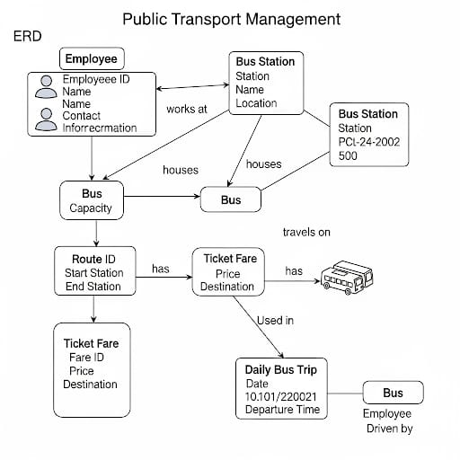

**Objects:**

* **Employee:** Represents transport staff (Drivers, Conductors).
* **Bus Station:** Represents physical bus stops/stations.
* **Bus:** Represents individual buses in the fleet.
* **Route:** Defines specific bus routes with start and end points.
* **Ticket Fare:** Stores fare details for different routes and bus types.
* **Daily Bus Trip:** Represents a single scheduled trip by a bus on a route with specific employees.

**Key Relationships:**

* **Employee ↔ Daily Bus Trip (Many-to-Many via Junction Object or Multiple Lookups):** An Employee can be on many trips (as driver or conductor), and a trip has multiple employees (driver, conductor).
* **Bus ↔ Daily Bus Trip (One-to-Many):** One Bus can have many Daily Bus Trips over time, but a single Daily Bus Trip is performed by one Bus.
* **Route ↔ Daily Bus Trip (One-to-Many):** One Route can have many Daily Bus Trips, but a single Daily Bus Trip follows one Route.
* **Ticket Fare ↔ Route (One-to-Many):** One Route can have many Ticket Fare types (e.g., adult, child), and a Ticket Fare belongs to one Route.

**Step 3: Idea Prioritization**

| Idea / Feature | Priority |
| --- | --- |
| Custom Salesforce data model (Employee, Bus Station, Bus, Ticket Fare, Daily Bus Trip, Route) | High |
| Dashboards and reports for passenger count and revenue | High |
| Automation of daily trip details (fare calculation, assignments) | High |
| Role-based access and permissions | High |
| Real-time insights for operational metrics | High |
| Automated alerts for trip management (e.g., upcoming trips, unassigned resources) | Medium |
| Mobile app optimization for trip updates | Low (future scope) |
| External ticketing system integration | Low (future scope) |

Prioritization was based on immediate impact, feasibility within the initial phase, and alignment with the Transport Department's goals of improving operational efficiency, data accuracy, and reporting capabilities